**The Mass Media and the Political Agenda**

* **Mass Media:**
  + Television, radio, ­­­­­­­­­__________________, magazines, the ­­­­­­­­­­­­­­_____________________and other means of popular communication
* **High-Tech Politics:**
  + A politics in which the __________________of citizens and policymakers and the political agenda itself are increasingly shaped by ___________________.
* **Effective communication through media is key to political success.**
  + Media Events: events ______________________staged for the media that nonetheless look spontaneous.
    - Media events can be staged by almost_________________.
  + Image making and news ______________________is important, especially for presidents.
* **Introduction**
  + The news media _______________always so important.
  + Press Conferences: meetings of public officials with reporters.
    - Franklin Roosevelt held over _________________
  + _____________________Journalism: the use of in-depth reporting to unearth scandals, scams & schemes putting reporters & politicians opposite each other.
  + Coverage of ______________________candidates has become less favorable.
* **The Print Media**
  + Newspapers and magazines
  + “______________________”: a sensational style of reporting characterized newspapers at the _____________ of the century.
  + Pecking order among newspapers
    - *____________________* has largest impact
  + Newspaper and newsweekly circulation has declined.
* **The Broadcast Media**
  + Television and ______________
  + Brought government and politics into peoples’ homes.
    - ________________ War
  + Politicians’ appearances and mannerisms more important.
    - _________________presidential debate
* **Government Regulation of the Broadcast Media**
  + The _____________________ _________________________ Commission (FCC) regulates the use of airwaves in three ways:
    - Prevent near ___________________control of market
    - Reviews performance of stations
    - Issues fair _______________rules for politicians
* **From Broadcasting to Narrowcasting: The Rise of Cable News Channels**
  + _____________________: media programming on cable TV or Internet that is focused on one topic and aimed at a particular audience, e.g., C-SPAN
  + Potential of _______________to report on news as it happens and offer myriad choices
  + Yet ___________________are limited and stories are not substantive
* **The Impact of the Internet**
  + Potential to ____________________Americans about politics
  + Internet is_____________________—people choose what to learn about
  + Since Americans are generally ________________________in politics, they will not necessarily use the Internet for political information.
  + ________________provide additional information about news stories.
* **Private Control of the Media**
  + Only a small number of TV stations are ___________________owned in America.
  + ________________________in what they can report, media are totally dependent on advertising revenues.
  + Chains: massive media _______________________that account for over four-fifths of the nation’s daily newspaper circulation
    - Also control broadcast media
* **Finding the News**
  + ___________________: specific locations from which news frequently emanates, such as Congress or the White House
  + Trial Balloons: an _____________________news leak for the purpose of assessing the political reaction
  + Reporters and their sources depend on each other—one for stories, the other to get them out.



* **Presenting the News**
  + *__________________*describes most news coverage today.
  + Sound Bites: short video clips of approximately ______________ seconds
  + Major TV networks devote _____________________ to covering political candidates

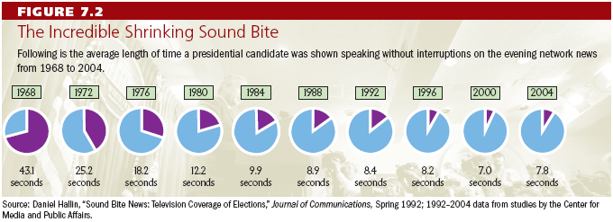

* **Bias in the News**
  + Many people believe the news is ____________________in favor of one point of view.
  + Generally is *not* very biased toward a ________________ideology
  + News reporting is biased towards what will draw the _________________audience—good pictures and negative reporting
* **Television news can affect what people think is important.**
  + **__________________-setting effect**
* **The media influence the __________________by which the public evaluates political leaders.**
* **Some stories or events can be made _____________important, others less important, depending on their_________________.**
* **_______________ Agenda**
  + **The issues that attract the ___________________attention of public officials and other people actively involved in politics at the time**
* **Policy Entrepreneurs**
  + **People who invest their political “_______________” in an issue to get it placed high on governmental agenda**
  + **Use media to raise __________________of issue**
* **The Media and the Scope of Government**
  + **Media as _______________restricts politicians**
  + **New proposals are met with ________________which restricts scope of government, what it can do**
  + **If media identifies a problem, it forces ___________________to address it, which expands the scope of government**
* **Individualism and the Media**
  + **________________run on their own by appealing to people on television**
  + **Easier to focus on one person like the president, than groups, e.g., Congress or the courts**
* **Democracy and the Media**
  + **“____________________is the fuel of democracy.”**
  + **But news provides more entertainment than information; it is superficial.**
  + **News is a business, _____________people what they want.**

**Summary**

* **Media __________________public opinion on political issues and influence policy agenda.**
* **Broadcast media have replaced print media over time.**
* **________________________ and the Internet are further shifting media.**
* **Seeking profits, media are biased in favor of stories with high drama.**

**Now go to: imeadows.weebly.com, then AP Gov, then watch short video titled Government made easy: Role of Media and write a few notes down from what you learned below.**

**____________________________________________________________________________________________________________________________________________________________________________________________________________________________________________________________________________________________________________________________________________________________________________________________________________________________________________________________________________________________________________________________________________________________________________________________________________________________________________________________________________________________________________________________________________________________________________________________________________________________________________________________________________________________________________________________________________________________________________________________________________________________________________________________**